Name: Moteba Rehman

Date: June 18, 2026

Topic: Carbon Footprint of Generative AI

Task: Understanding CO2 Tracking tools

Supervisor: Ms. Zahida Kausar

Faculty Coordinator: Dr. Mewish Fatima

Introduction:
The objective of this task was to explore the outputs generated by carbon accounting tools and compare the measurements they provide for different computational workloads. For this activity, I used CodeCarbon and CarbonTracker to monitor three simple Python programs: a Python loop, sorting a large array, and matrix multiplication.
Experiment Logs:
Test Programs
- Simple Python Loop
- Sorting a Large Array
- Matrix Multiplication
These programs were executed using both CodeCarbon and CarbonTracker.
Results:
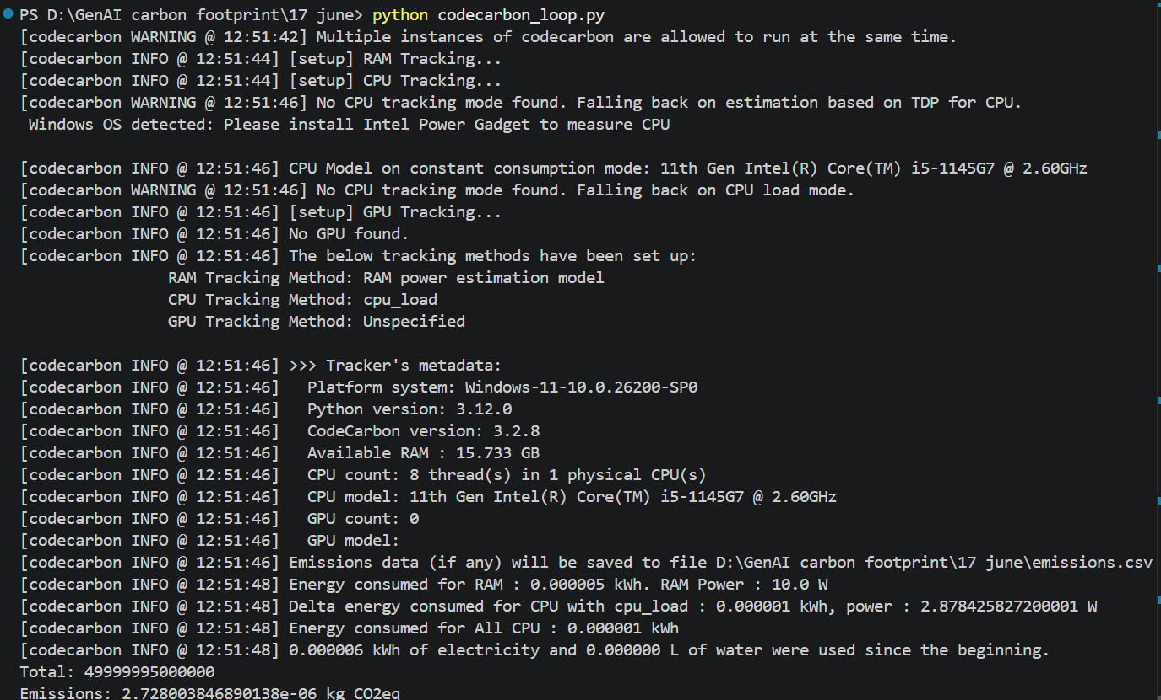
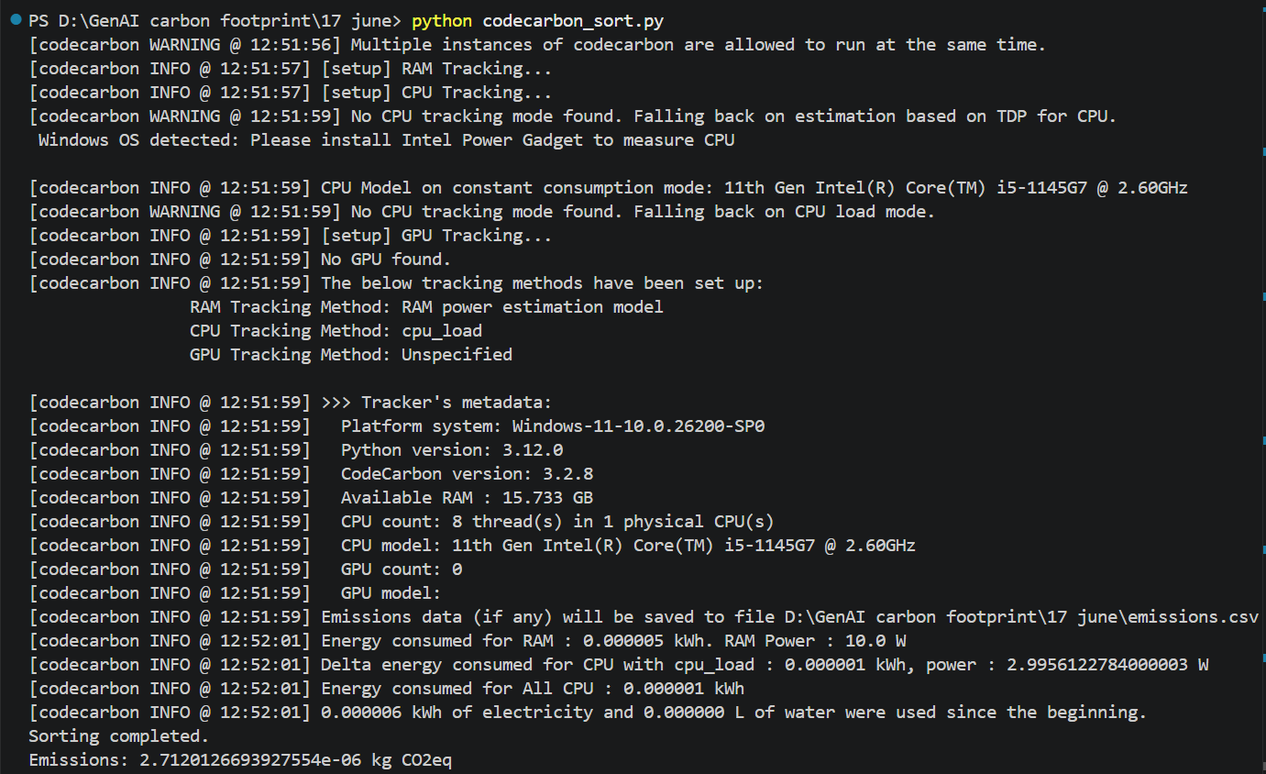
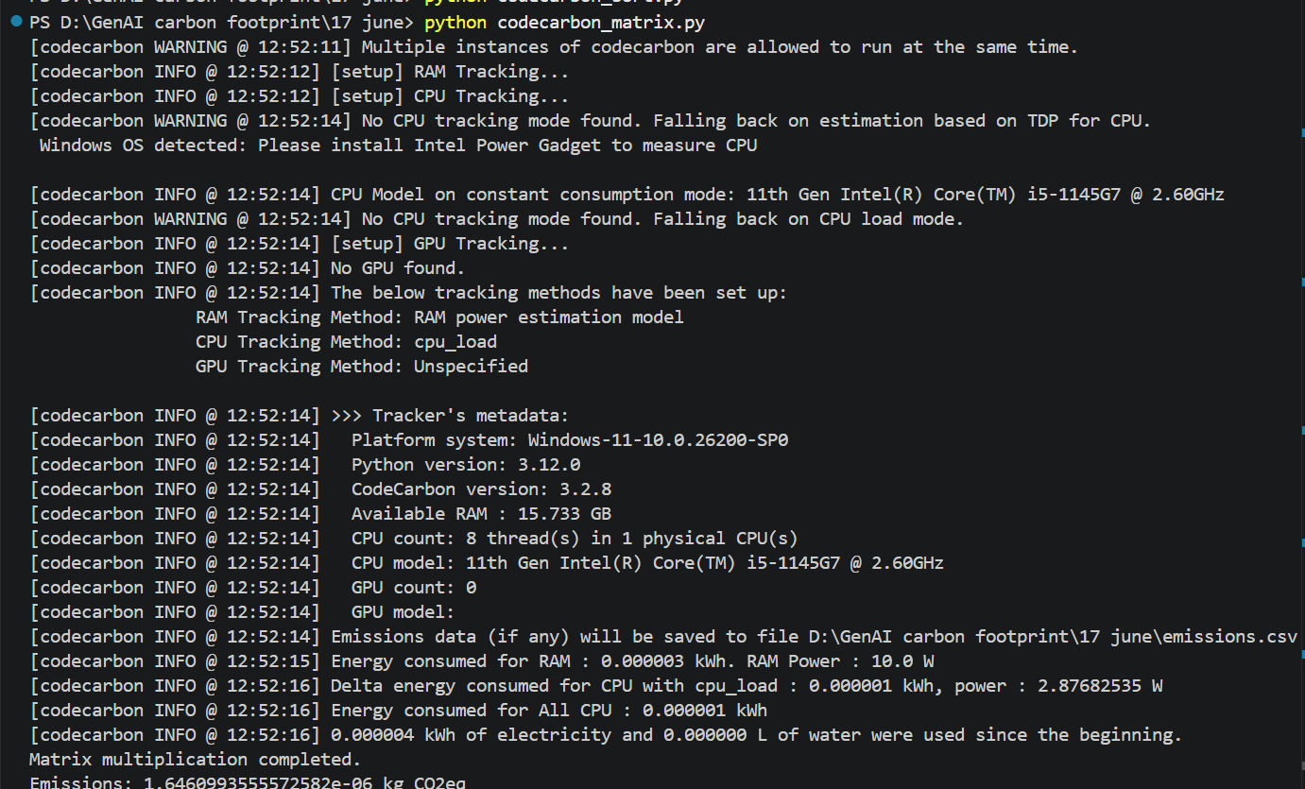
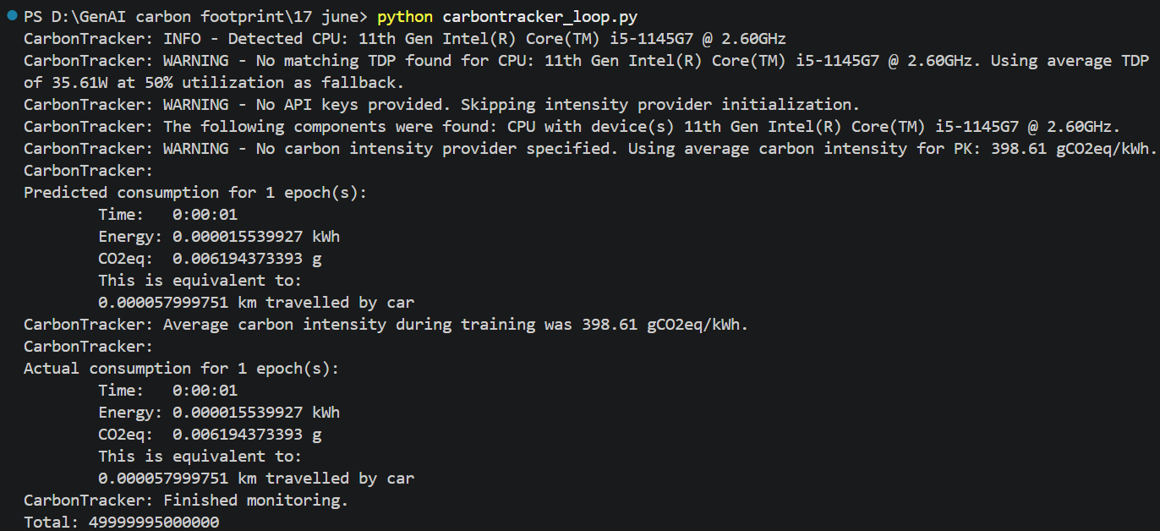
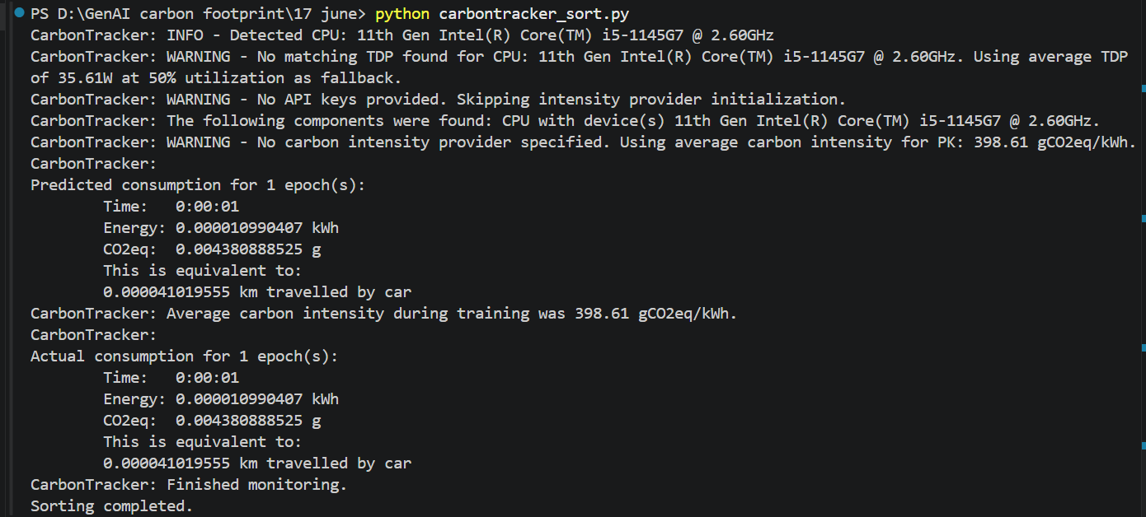
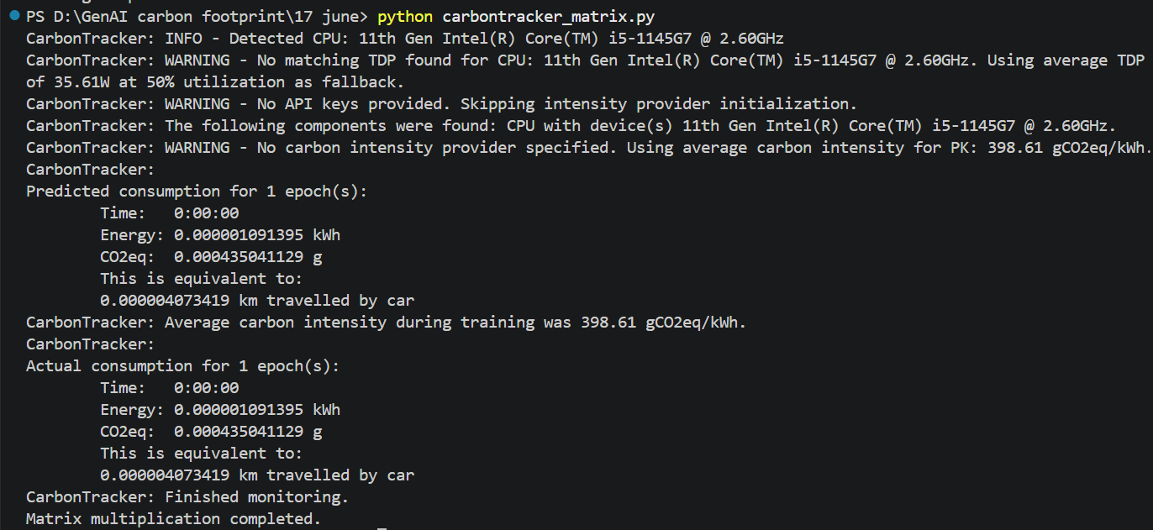
Comparison Table:
Criteria | CodeCarbon | CarbonTracker
Installation Difficulty | Easy | Easy
Ease of Use | Very Easy | Easy
Energy Consumption Reporting | Yes (kWh) | Yes (kWh)
Carbon Emission Reporting | Yes (CO₂eq) | Yes (CO₂eq)
Output Detail | High | Moderate
Suitable for AI Experiments | Yes | Yes

Observations:
During testing, I noticed that both tools were able to estimate energy consumption and carbon emissions successfully. However, the values reported by the tools were not identical even when running relatively simple programs.
CodeCarbon provided more detailed information, including CPU and RAM energy estimates, system information, and CSV reports. CarbonTracker provided a simpler summary focused on energy usage, carbon emissions, and runtime.
Both tools displayed warnings indicating that direct CPU power measurements were not available on my system, so they relied on estimation methods. This is likely one of the reasons why the reported values differ.
Reflection:
This was my first experience working with carbon accounting tools. I found both tools easy to install and use.
Among the two, CodeCarbon was slightly easier to work with because it automatically generated detailed reports and provided more information about system resource usage. CarbonTracker was also straightforward but focused more on summary statistics.
The main takeaway from this task is that different carbon accounting tools may produce different estimates because they use different assumptions, power models, and carbon intensity data. Although the exact values vary, both tools are useful for understanding the environmental impact of software execution.
For future AI or machine learning experiments, I would prefer using CodeCarbon because of its detailed reporting and additional hardware information.

